Spectral coherence: AUDUSD and NZDUSD
Method 21 / daily log returns / Welch magnitude-squared coherence / Alpari D1 full available history

Study setup
Logical pair: AUDUSD , NZDUSD
Broker symbols: AUDUSD_i , NZDUSD_i
Snapshot: 2026-11-03_majors_alpari_D1
Timeframe: D1
Matched return window: 1999-01-05 to 2026-11-02 (UTC bar dates)
Matched return count n: 7202
Dropped unfinished last bar dated 2026-11-03 UTC after a tick-volume check against the prior complete day.
Welch: fs=1.0, nperseg=256, noverlap=128, window=hann, detrend=constant
Headline: gamma^2 nearest f=1/5; also 1/21 and 1/63
Complete matched rows (Excel): AUDUSD-NZDUSD_Spectral_D1.xlsx
Complete matched rows (HTML table): AUDUSD-NZDUSD_Spectral_D1_data.html

Method carried forward
Magnitude-squared spectral coherence gamma^2(f) measures shared linear power between matched daily log returns of close, ln(close_t / close_t-1), at each frequency f (cycles per day). Quotes are not inverted. Welch settings are frozen: fs=1, nperseg=256, noverlap=128, window=hann, detrend=constant. Headline is gamma^2 at the frequency bin nearest f=1/5 (five-day cycle from the formula sheet). Also reported: gamma^2 nearest f=1/21 and f=1/63, mean gamma^2 over the frequency grid, and phase of the cross-spectrum at the 1/5 bin. Coherence is unsigned (0 to 1); phase carries timing. Same-sample Pearson r is a side check only. This is not causation and not a trading signal.

Results (headline)
gamma^2 near 1/5: 0.672850
bin f (1/5): 0.199219
phase at 1/5 (rad): -0.207142
gamma^2 near 1/21: 0.696488
gamma^2 near 1/63: 0.698663
mean gamma^2: 0.696966
Pearson r: 0.828722

Target-frequency summary
period | target_f | f_bin | gamma2 | phase_rad
5 | 0.2 | 0.19921875 | 0.67285 | -0.20714162
21 | 0.04761905 | 0.046875 | 0.69648788 | -0.01446888
63 | 0.01587302 | 0.015625 | 0.69866298 | -0.10579128

Conclusion
Headline gamma^2 near f=1/5 for AUDUSD and NZDUSD: 0.6729 (bin f=0.199219, phase=-0.2071 rad). At ~1/21: 0.6965; at ~1/63: 0.6987. Mean gamma^2 = 0.6970. Pearson r = 0.8287. This is frequency-domain linkage, not a trading signal.

Charts
Daily closes

Daily log returns

Spectral coherence gamma^2(f)
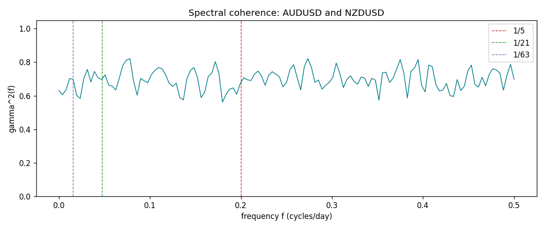

Data report
Matched rows and the coherence sheet are in the sibling Excel workbook named AUDUSD-NZDUSD_Spectral_D1.xlsx. Embedding all rows as a Word table is impractical; this file holds column summaries and the first and last 15 matched rows.
Columns: time, AUDUSD_open, NZDUSD_open, AUDUSD_high, NZDUSD_high, AUDUSD_low, NZDUSD_low, AUDUSD_close, NZDUSD_close, AUDUSD_tick_volume, NZDUSD_tick_volume, AUDUSD_spread, NZDUSD_spread, AUDUSD_real_volume, NZDUSD_real_volume, AUDUSD_log_return, NZDUSD_log_return
Column summaries (matched calculation rows)
column | count | mean | std | min | 25% | 50% | 75% | max
AUDUSD_open | 7202 | 0.75190973 | 0.13530408 | 0.4785 | 0.6610275 | 0.731395 | 0.8089525 | 1.10284
NZDUSD_open | 7202 | 0.65620671 | 0.10825448 | 0.3913 | 0.5910925 | 0.6683 | 0.724695 | 0.88218
AUDUSD_high | 7202 | 0.75595988 | 0.13586572 | 0.4878 | 0.6647 | 0.734725 | 0.81501 | 1.10795
NZDUSD_high | 7202 | 0.66012182 | 0.1087492 | 0.3961 | 0.5946275 | 0.67189 | 0.7292675 | 0.88421
AUDUSD_low | 7202 | 0.74785283 | 0.13461673 | 0.4775 | 0.6577 | 0.727385 | 0.8042 | 1.0975
NZDUSD_low | 7202 | 0.6525168 | 0.10784895 | 0.3897 | 0.587955 | 0.66406 | 0.72082 | 0.87988
AUDUSD_close | 7202 | 0.75195766 | 0.13528533 | 0.4786 | 0.6611925 | 0.731645 | 0.809065 | 1.10169
NZDUSD_close | 7202 | 0.65627751 | 0.10825012 | 0.3907 | 0.59141 | 0.668305 | 0.7249175 | 0.8822
AUDUSD_tick_volume | 7202 | 77337.3 | 138128.78 | 109 | 5435.5 | 43320 | 71312.25 | 1234623
NZDUSD_tick_volume | 7202 | 68561.899 | 123036.41 | 17 | 5505.5 | 33822 | 58470.25 | 1127682
AUDUSD_spread | 7202 | 30.821161 | 16.887481 | 0 | 13 | 30 | 50 | 50
NZDUSD_spread | 7202 | 30.366287 | 25.672101 | 0 | 9 | 17 | 50 | 80
AUDUSD_real_volume | 7202 | 5.2413627e+09 | 1.253718e+11 | 0 | 0 | 0 | 0 | 3.811512e+12
NZDUSD_real_volume | 7202 | 1.6659405e+10 | 8.488719e+10 | 0 | 0 | 0 | 0 | 2.705649e+12
AUDUSD_log_return | 7202 | 2.237e-05 | 0.00754318 | -0.08602525 | -0.00386318 | 0.00028132 | 0.00415217 | 0.0806166
NZDUSD_log_return | 7202 | 5.13e-06 | 0.00764596 | -0.07027433 | -0.00426304 | 0.00021271 | 0.00457975 | 0.05966839
First 15 matched rows (selected columns)
time | AUDUSD_log_return | NZDUSD_log_return
1999-01-05 | -0.00080418179 | -0.0018597736
1999-01-06 | 0.011836351 | 0.0020455609
1999-01-07 | 0.0088650256 | 0.0062963171
1999-01-08 | 0.00031515916 | -0.00055396548
1999-01-11 | 0.0072213815 | 0.010290425
1999-01-12 | -0.0048608485 | -0.0053157489
1999-01-13 | -0.0078902098 | -0.0099742238
1999-01-14 | -0.002696916 | -0.00018564931
1999-01-15 | 0.007123101 | -0.00074294208
1999-01-18 | 0.00094592471 | -0.0018597736
1999-01-19 | 0.0072225153 | 0.0018597736
1999-01-20 | 0.0012507819 | 0.0040793678
1999-01-21 | 0.00078094498 | 0.0040627941
1999-01-22 | -0.012252745 | -0.012051689
1999-01-25 | -0.0039591468 | -0.0035504102
Last 15 matched rows (selected columns)
time | AUDUSD_log_return | NZDUSD_log_return
2026-10-13 | 0.0035007712 | 0.0047326165
2026-10-14 | -0.0015193215 | -0.0037306483
2026-10-15 | -0.0075447063 | 0.0047634855
2026-10-16 | 0.0033906408 | 0.0057501001
2026-10-19 | 0.0050859986 | 0.0018917133
2026-10-20 | 0.0034620426 | 0.0037199341
2026-10-21 | 0.0036066384 | 0.0030923331
2026-10-22 | -0.0012672558 | -0.0033035227
2026-10-23 | 0.0023765656 | 0.0030929853
2026-10-26 | -0.0032032829 | -0.0028993932
2026-10-27 | 0.0016669876 | -0.00026399852
2026-10-28 | 0.0040915541 | -0.0097283914
2026-10-29 | -0.0040915541 | 0.00062190714
2026-10-30 | 0.0010102376 | 0.00019537668
2026-11-02 | -0.0049184984 | -0.0025962955
First 15 frequency bins
f | gamma2 | phase_rad | period_days
0 | 0.63170738 | 0 | inf
0.00390625 | 0.60603813 | -0.03455029 | 256
0.0078125 | 0.6342783 | 0.00748745 | 128
0.01171875 | 0.70235176 | 0.03322251 | 85.333333
0.015625 | 0.69866298 | -0.10579128 | 64
0.01953125 | 0.60130792 | -0.04144891 | 51.2
0.0234375 | 0.58389567 | -0.05214441 | 42.666667
0.02734375 | 0.70248973 | -0.04068144 | 36.571429
0.03125 | 0.75702161 | -0.08466808 | 32
0.03515625 | 0.68212753 | -0.05455308 | 28.444444
0.0390625 | 0.74488583 | 0.05262437 | 25.6
0.04296875 | 0.70754508 | -0.06817463 | 23.272727
0.046875 | 0.69648788 | -0.01446888 | 21.333333
0.05078125 | 0.72450243 | -0.00109404 | 19.692308
0.0546875 | 0.66344281 | 0.01924681 | 18.285714

